# Mock ICT -2023

## Question 1

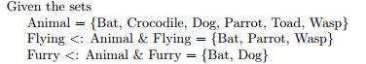

1. Flying\/Furry = {Bat, Parrot, Wasp, Dog}
2. Animal-Furry = {Crocodile, Parrot, Toad, Wasp}
3. Furry /\ Flying = {Bat}

Card (Furry/\Flying) = 1

1. Card ({Flying}) = 1

Card (Flying)=1

1. POW(Furry) = {{Bat, Dog}, {Bat}, {Dog}, {}}

POW(Flying) = {{}, {Bat, Parrot, Wasp}, {Bat, Parrot}, {Bat, Wasp}, {Parrot, Wasp}, {Bat}, {Parrot}, {Wasp}}

## Question 2



(A<: B) 🡪 false

(B<A) 🡪 false

|  |  |  |
| --- | --- | --- |
| P | Q | P⬄Q |
| T | T | T |
| F | T | F |
| T | F | F |
| F | F | T |

1. (A<: B) ⬄ (B<<: A) = True

A is a subset of B

if and only if

B is a strictly subset of A

1 ∈ A 1+1 = 2∈B

2∈A 2+1 = 3∈B

3∈B 3+1 = 4∉B

1. ! (n).(n: A 🡺 n+1 : B) = False

For all **n**, in A implies n+1 in B

2 ∈ B 2+1 = 3∈A

7 ∈ B 7+1 = 8∉A

1. #(n).(n : B & n+1 : A) = True

For some in B, n+1 is in A

1. ! (n). (n: A 🡺 #(m). (m : B & m < n)) = False

For every element of A, there is some element of B such that m < n

1∈A <1

∈B

1 ∈ A, but we cannot find an element from B which is less than 1

1. #(n). (n: A &! (m). (m: B 🡺 m<n))

Bebeb

## Question 3

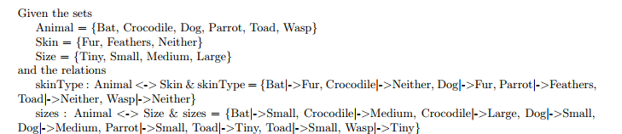

1. source = ANIMAL

Dom (Skin Type) = {Bat, Crocodile, Dog, Parrot, Toad, Wasp}

Ran(Skin Type) = SKIN

Relation 🡺 function 🡺 Total

* Surjective

1. ANIMAL*SKIN – {(Bat, Fur),(bat, Feather), (Bat, Neither), (Crocodile, Fur), (Crocodile, Feather), (Crocodile, Neither),…}

ANIMAL*SKIN – Skin Type = {(Bat, Feather), (Bat, Neither), (Crocodile, Fur),(Crocodile, Feather), (Dog, Feather, Fur), (Dog, Neither), (Parrot, Fur), (Parrot, Neither), (Toad, Fur),

Dom (ANIMAL*SKIN-Skin Type) = {Bat, Crocodile, Dog, Parrot, Toad, Wasp}

1. SkinType~ 🡺 {(Fur, Bat), (Neither, Crocodile), (Fur, Dog), (Feathers, Parrot), (Neither, Toad), (Neither, Wasp)}
2. (sizes~; SkinType)

Sizes~ 🡺 {(Small, Bat), (Medium, Crocodile), (Large, Crocodile), (Small, Dog), (Medium, Dog), (Small, Parrot), (Tiny, Parrot), (Small, Toad), (Tiny, Wasp)}

(Sizes~ ; SkinType) 🡺 {Tiny|-> Neither, Small|-> Fur, Small|-> Feather, Small |-> Neither, Medium|-> Neither, Medium|->Fur, Large|->Neither}

1. Sizes[{Toad}] 🡺 {Small, Tiny}

## Question 04

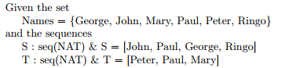

1. S ^ T = [John, Paul, George, Ringo, Peter, Paul, Mary]
2. Ran (T) = {Peter, Paul, Marry}
3. Jon -> S = [John, John, Paul, George, Ringo]
4. S/\ T = {(1, John), (2, Paul), (3, George), (4, Ringo)}/\ {(1, Peter), (2, Paul), (3, Marry) }

= {(2, Paul)}

1. Tail(S) = {Paul, George, Ringo}

